**Cài đặt RAC 2 node**

# **Step 1: Configure file /etc/hosts trên 02 server**

* (bash – root): vi /etc/hosts

127.0.0.1 localhost localhost.localdomain localhost4 localhost4.localdomain4

::1 localhost localhost.localdomain localhost6 localhost6.localdomain6

# Public

192.168.56.11 rac1.localdomain rac1

192.168.56.12 rac2.localdomain rac2

# Private

192.168.57.11 rac1-priv.localdomain rac1-priv

192.168.57.12 rac2-priv.localdomain rac2-priv

# Virtual IP

192.168.56.13 rac1-vip.localdomain rac1-vip

192.168.56.14 rac2-vip.localdomain rac2-vip

# SCAN

192.168.56.15 rac-scan.localdomain rac-scan

192.168.56.16 rac-scan.localdomain rac-scan

192.168.56.17 rac-scan.localdomain rac-scan

# DNS

192.168.56.18 dnsss.localdomain dnsss

# **Step 2: Configure hotsname**

* (bash – root – node1): hostnamectl set-hostname rac1.localdomain
* (bash – root – node2): hostnamectl set-hostname rac2.localdomain

# **Step 3: Off firewalld**

* (bash – root – node1 + 2): systemctl stop firewalld.service
* (bash – root – node1 + 2): systemctl disable firewalld.service

# **Step 4: Bật đồng bộ thời gian**

* (bash – root – node1 + 2): yum install chrony.service
* (bash – root – node1 + 2): systemctl enable chronyd.service
* (bash – root – node1 + 2): systemctl restart chronyd.service
* (bash – root – node1 + 2): systemctl status chronyd.service
* (bash – root – node1 + 2): chronyc tracking
* (bash – root – node1 + 2): chronyc sources
* (bash – root – node1 + 2): chronyc -a ‘burst 4/4’
* (bash – root – node1 + 2): chronyc -a makestep

# **Step 5: Upgrade and install oracleasm, preinstall**

* (bash – root – node 1 + 2): yum update -y
* (bash – root – node 1 + 2): yum list | grep oracleasm -i
* (bash – root – node 1 + 2): yum install oracleasm-support -y
* (bash – root – node 1 + 2): yum list | grep oracleasm -i
* (bash – root – node 1 + 2): yum install oracle-database-preinstall-19c.x86_64 -y

# **Step 6: Tạo các nhóm cho oracleasm**

* (bash – root – node 1 + 2 ): groupadd asmdba
* (bash – root – node 1 + 2 ): groupadd asmoper
* (bash – root – node 1 + 2 ): groupadd asmadmin

# **Step 7: Tạo user và gán quyền**

* (bash – root – node 1 + 2 ): passwd oracle

--- >>> double fill password

* (bash – root – node 1 + 2 ): useradd -g oinstall -G asmadmin,asmdba,asmoper,dba grid
* (bash – root – node 1 + 2 ): passwd grid

--- >>> double fill password

* (bash – root – node 1 + 2 ): usermod -g oinstall -G dba,oper,backupdba,dgdba,kmdba,asmdba,asmoper,asmadmin,racdba oracle
* (bash – root – node 1 + 2 ): usermod -g oinstall -G dba,oper,backupdba,dgdba,kmdba,asmdba,asmoper,asmadmin,racdba grid

# **Step 8: Tạo đường dẫn**

* (bash – root – node 1 + 2 ): mkdir -p /u01/app/19c/grid
* (bash – root – node 1 + 2 ): mkdir -p /u01/app/grid
* (bash – root – node 1 + 2 ): mkdir -p /u01/app/oracle/product/19c/dbhome_1
* (bash – root – node 1 + 2): chown -R grid:oinstall /u01
* (bash – root – node 1 + 2): chown -R oracle:oinstall /u01/app/oracle

# **Step 9: Tạo biến bash_profile**

======Node 1======

* (bash – root – node 1): su – oracle
* (bash – oracle – node 1): vi .bash_profile
* (bash – oracle – node 1): . .bash_profile

export TMP=/tmp

export TMPDIR=$TMP

export ORACLE_BASE=/u01/app/oracle

export GRID_HOME=/u01/app/19c/grid

export DB_HOME=$ORACLE_BASE/product/19c/dbhome_1

export ORACLE_HOME=$DB_HOME

export ORACLE_SID=orcl1

export ORACLE_TERM=xterm

export BASE_PATH=/usr/sbin:$PATH

export PATH=$ORACLE_HOME/bin:$BASE_PATH

export LD_LIBRARY_PATH=$ORACLE_HOME/lib:/lib:/usr/lib

export CLASSPATH=$ORACLE_HOME/JRE:$ORACLE_HOME/jlib:$ORACLE_HOME/rdbms/jlib

* (bash – root – node 2): su – oracle
* (bash – oracle – node 2): vi .bash_profile
* (bash – oracle – node 2): . .bash_profile

export TMP=/tmp

export TMPDIR=$TMP

export ORACLE_BASE=/u01/app/oracle

export GRID_HOME=/u01/app/19c/grid

export DB_HOME=$ORACLE_BASE/product/19c/dbhome_1

export ORACLE_HOME=$DB_HOME

export ORACLE_SID=orcl2

export ORACLE_TERM=xterm

export BASE_PATH=/usr/sbin:$PATH

export PATH=$ORACLE_HOME/bin:$BASE_PATH

export LD_LIBRARY_PATH=$ORACLE_HOME/lib:/lib:/usr/lib

export CLASSPATH=$ORACLE_HOME/JRE:$ORACLE_HOME/jlib:$ORACLE_HOME/rdbms/jlib

* (bash – root – node 1): su – grid
* (bash – grid – node 1): vi .bash_profile
* (bash – grid – node 1): . .bash_profile

export ORACLE_SID=+ASM1

export ORACLE_HOME=/u01/app/19c/grid

export BASE_PATH=/usr/sbin:/usr/bin:/sbin:/bin:/usr/local/bin

export PATH=$ORACLE_SID/bin:$BASE_PATH

export LD_LIBRARY_PATH=$ORACLE_SID/lib:/lib:/usr/lib

export CLASSPATH=$ORACLE_SID/JRE:$ORACLE_SID/jlib:$ORACLE_SID/rdbms/jlib

* (bash – root – node 2): su – grid
* (bash – grid – node 2): vi .bash_profile
* (bash – grid – node 2): . .bash_profile

export ORACLE_SID=+ASM2

export ORACLE_SID=/u01/app/19c/grid

export BASE_PATH=/usr/sbin:/usr/bin:/sbin:/bin:/usr/local/bin

export PATH=$ORACLE_SID/bin:$BASE_PATH

export LD_LIBRARY_PATH=$ORACLE_SID/lib:/lib:/usr/lib

export CLASSPATH=$ORACLE_SID/JRE:$ORACLE_SID/jlib:$ORACLE_SID/rdbms/jlib

# **Step 10: Add đĩa vào máy ảo**

* Shutdown 2 node
* Tạo đĩa ảo, type: shareable
* Add đĩa ảo

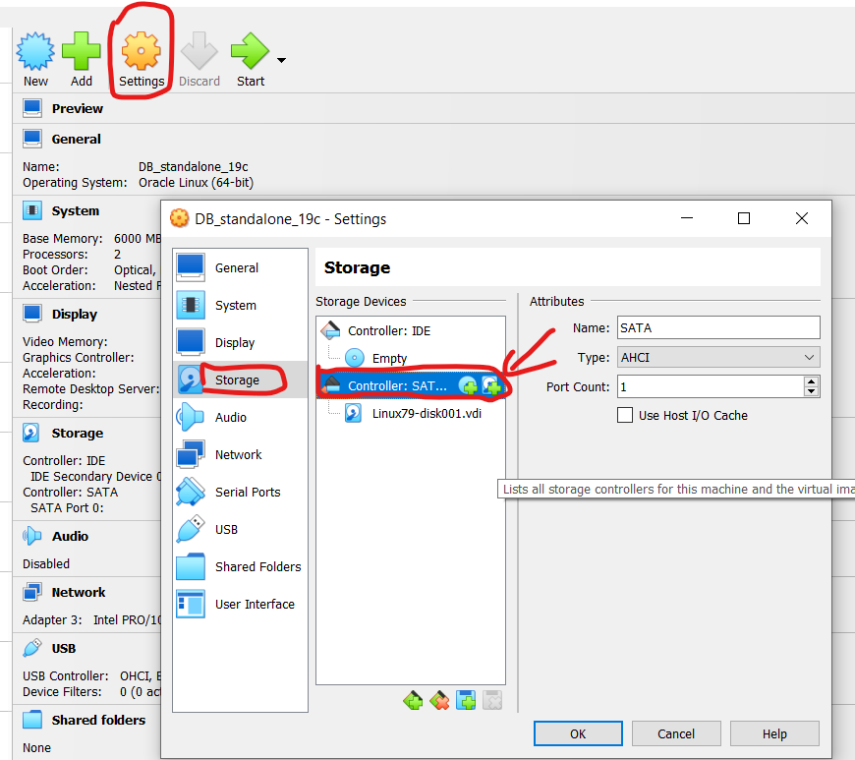



Start 2 node:

* Ping test

ping -c 2 rac1

ping -c 2 rac2

ping -c 2 rac1-priv

ping -c 2 rac2-priv

**Trên node 1**

# **Step 11: Giải nén file cài đặt**

* (bash – root – node 1): su –
* (bash – root – node 1): cd /u01/app/19c/grid/
* (bash – root – node 1): unzip /home/oracle/193000_grid_home.zip
* (bash – root – node 1): cd /u01/app/oracle/product/19c/dbhome_1
* (bash – root – node 1): unzip /home/oracle/193000_db_home.zip
* (bash – root – node 1): chown -R grid:oinstall /u01
* (bash – root – node 1): chown -R oracle:oinstall /u01/app/oracle

# **Step 12: Cài đặt CVU trên cả 2 node**

**Cluster Verification Utility (CVU)** có thể **phát hiện các ổ đĩa dùng chung (shared disks)** trên cả 2 node (rac1, rac2) trước khi cài đặt Oracle Grid Infrastructure.

* (bash – root – node 1): cd /u01/app/19c/grid/cv/rpm
* (bash – root – node 1): rpm -Uvh cvuqdisk*

Copy file node 2 và cài đặt CVU disk

* (bash – root – node 1): scp ./cvuqdisk* root@rac2:/tmp
* (bash – root – node 1): ssh root@rac2 rpm -Uvh /tmp/cvuqdisk*

# **Step 13: Định dạng ở đĩa**

* (bash – root – node 1): fdisk -l
* (bash – root – node 1): fdisk /dev/sdb

n new

p primary

enter

enter

enter

w write

* Tương tự với fdisk /dev/sdc và fdisk /dev/sdd

# **Step 14: Cấu hình ASM node 1**

* (bash – root – node 1): su –
* (bash – root – node 1): /usr/sbin/oracleasm configure -i
* (bash – root – node 1): grid
* (bash – root – node 1): oinstall
* (bash – root – node 1): y
* (bash – root – node 1): y

### verify

* (bash – root – node 1): /usr/sbin/oracleasm configure

### init

* (bash – root – node 1): /usr/sbin/oracleasm status
* (bash – root – node 1): /usr/sbin/oracleasm init
* (bash – root – node 1): /usr/sbin/oracleasm status

### check

* (bash – root – node 1): df -ha | grep oracle

# **Step 15: Tạo ASM Disk tương ứng với từng đĩa**

* (bash – root – node 1): oracleasm createdisk DATA /dev/sdb1
* (bash – root – node 1): oracleasm createdisk FRA /dev/sdc1
* (bash – root – node 1): oracleasm createdisk OCR /dev/sdd1

## quét và check đĩa DG

* (bash – root – node 1): oracleasm scandisks
* (bash – root – node 1): oracleasm listdisks

# **Step 16: Configure SSH cho cả 2 user grid và user oracle**

* (bash – root – node 1): ssh-keygen -t rsa
* (bash – root – node 1): ssh-copy-id -i ~/.ssh/id_rsa.pub oracle@rac2
* (bash – root – node 1): ssh-copy-id -i ~/.ssh/id_rsa.pub grid@rac2
* (bash – root – node 2): ssh-keygen -t rsa
* (bash – root – node 2): ssh-copy-id -i ~/.ssh/id_rsa.pub oracle@rac1
* (bash – root – node 2): ssh-copy-id -i ~/.ssh/id_rsa.pub grid@rac1

**Trên node 2**

# **Step 17: Cấu hình ASM node 2**

* (bash – root – node 2): su –
* (bash – root – node 2): /usr/sbin/oracleasm configure -i
* (bash – root – node 2): grid
* (bash – root – node 2): oinstall
* (bash – root – node 2): y
* (bash – root – node 2): y

### verify

* (bash – root – node 2): /usr/sbin/oracleasm configure

### init

* (bash – root – node 2): /usr/sbin/oracleasm status
* (bash – root – node 2): /usr/sbin/oracleasm init
* (bash – root – node 2): /usr/sbin/oracleasm status

### check

* (bash – root – node 2): df -ha | grep oracle

**Trên node 1**

# **Step 18: Cài đặt grid – Node 1 – User Grid**

* (bash – root – node 1): su grid
* (bash – root – node 1): cd
* (bash – root – node 1): cd /u01/app/19c/grid/
* (bash – root – node 1): ./runcluvfy.sh stage -pre crsinst -n rac1,rac2 -verbose
* (bash – root – node 1): export DISPLAY=192.168.68.222:0.0
* (bash – root – node 1): cd /u01/app/19c/grid/
* (bash – root – node 1): ./gridSetup.sh

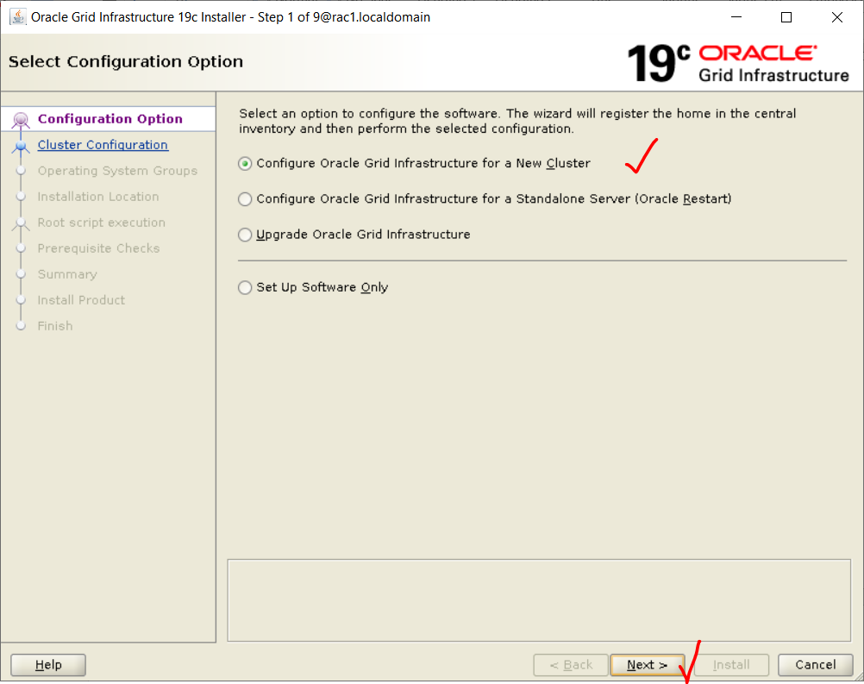

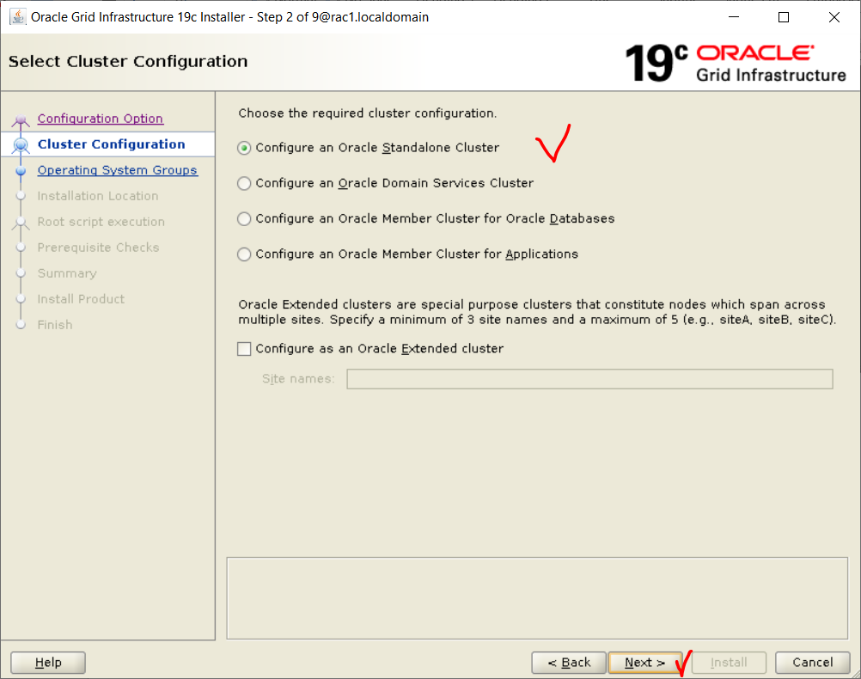



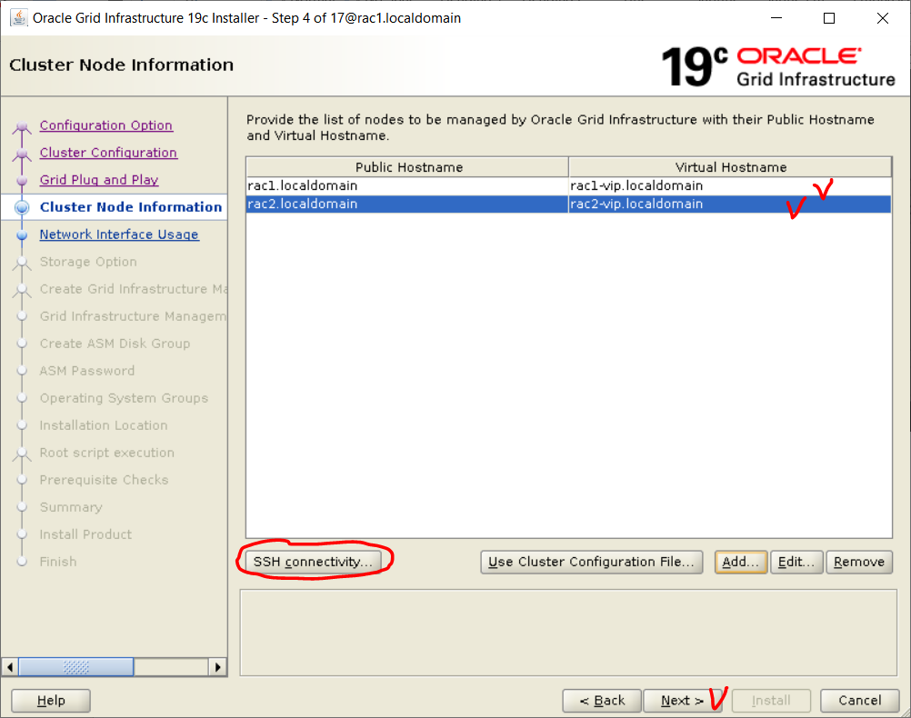

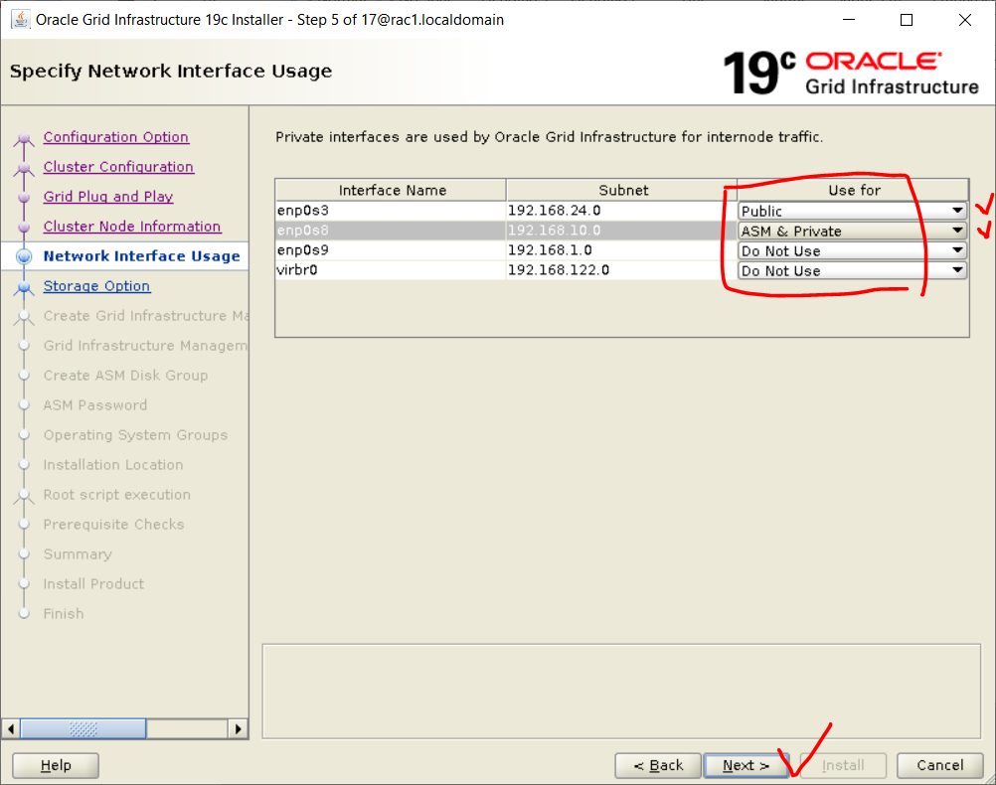

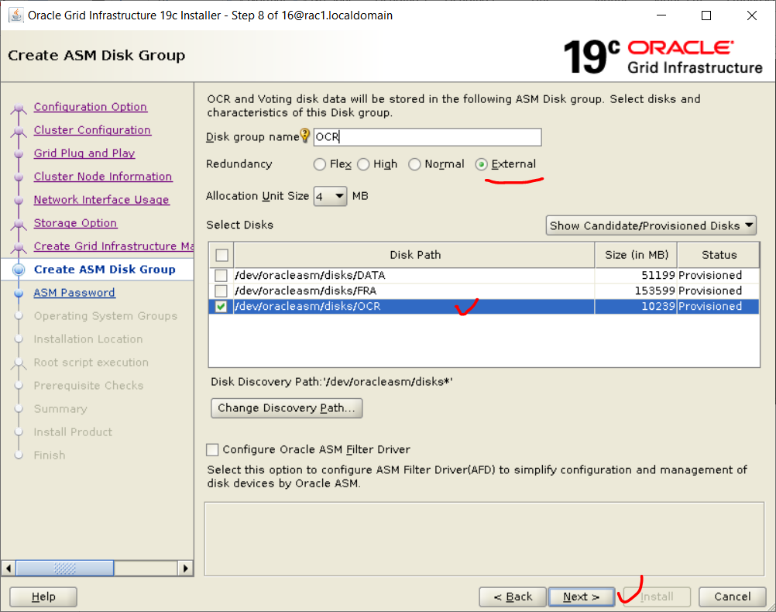

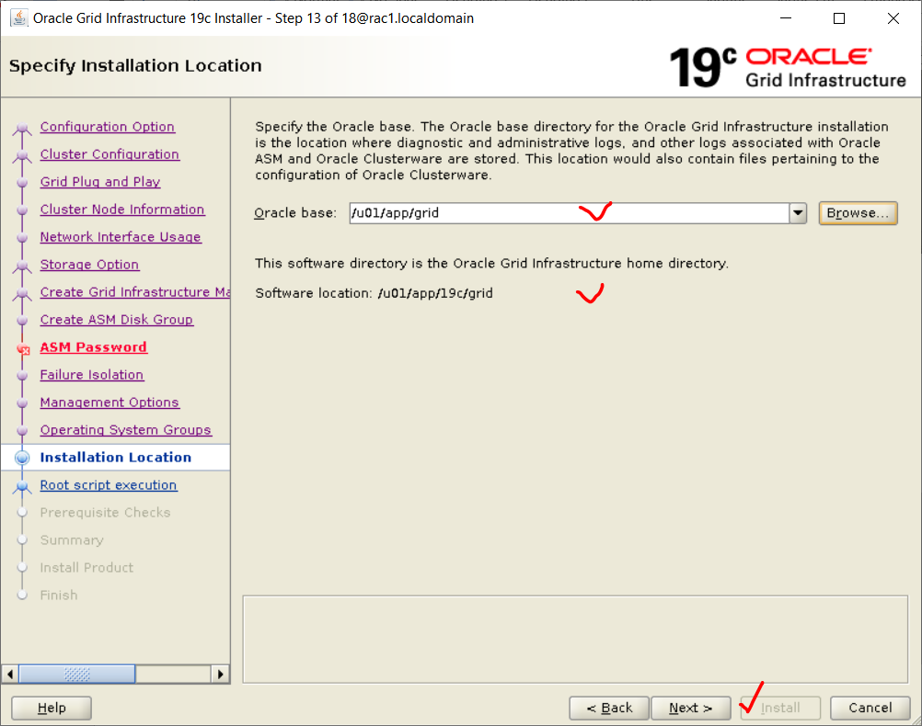

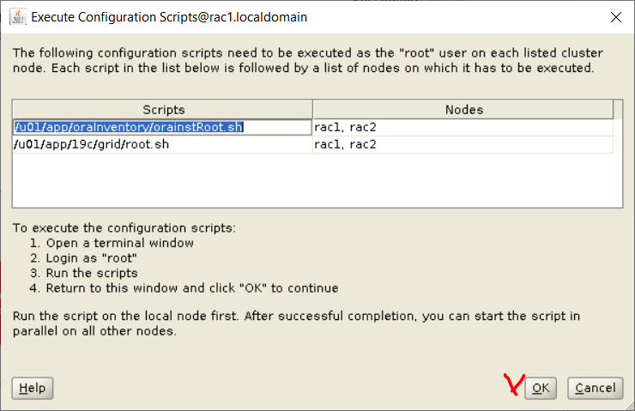

Kiểm tra thông tin GRID

cd /u01/app/19c/grid/bin

./crsctl check cluster -all

./crsctl status resource -t

# **Step 19: Cài đặt Oracle Database – Node 1**

su oracle

cd

. .bash_profile

cd /u01/app/oracle/product/19c/dbhome_1/

./runInstaller

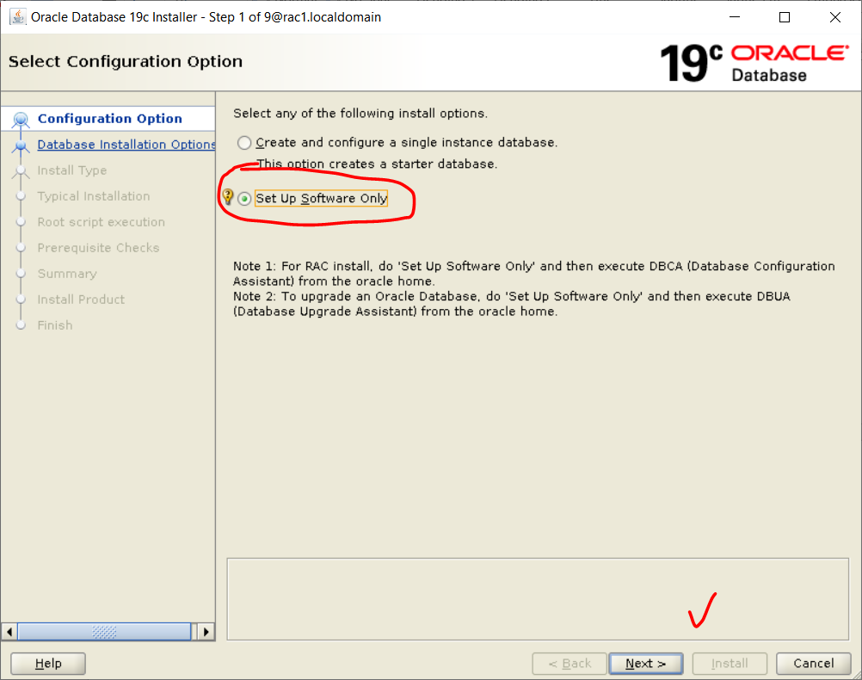

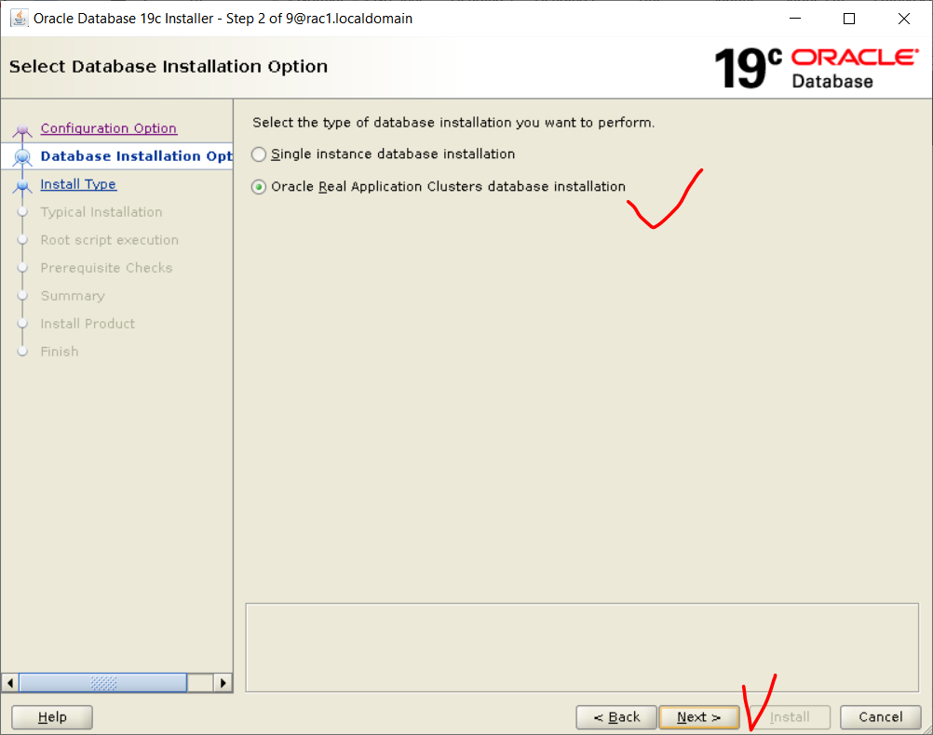

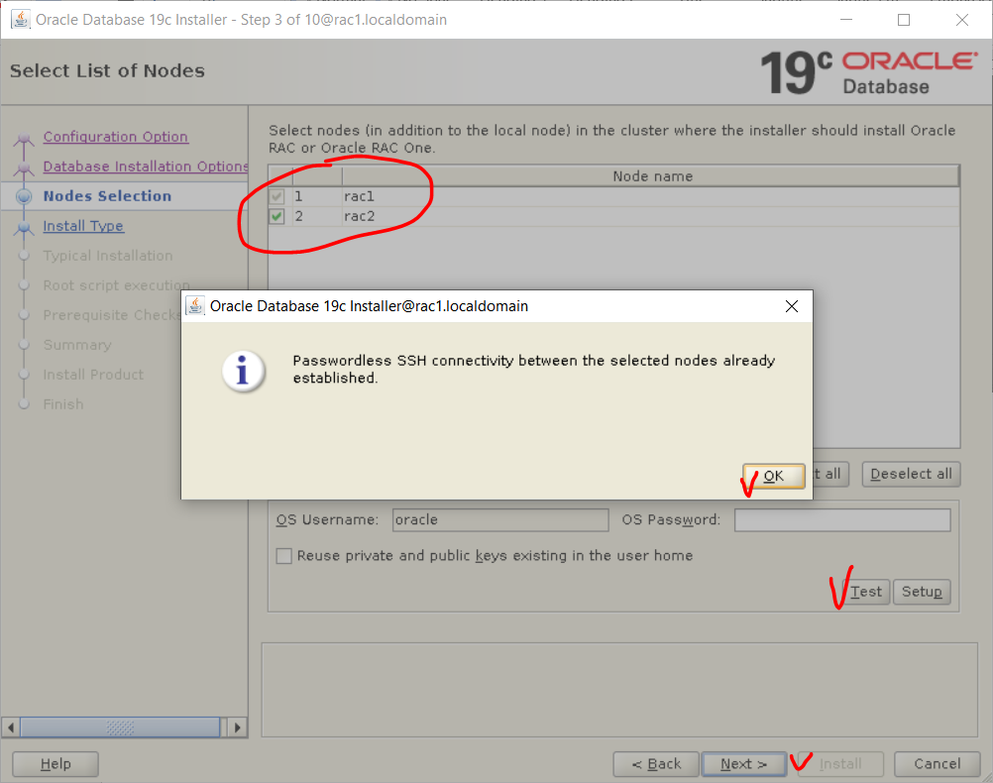

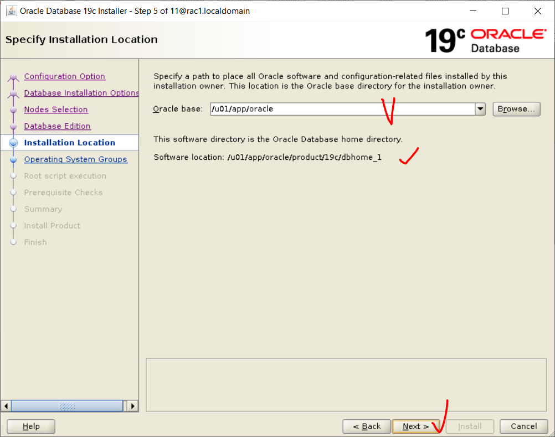

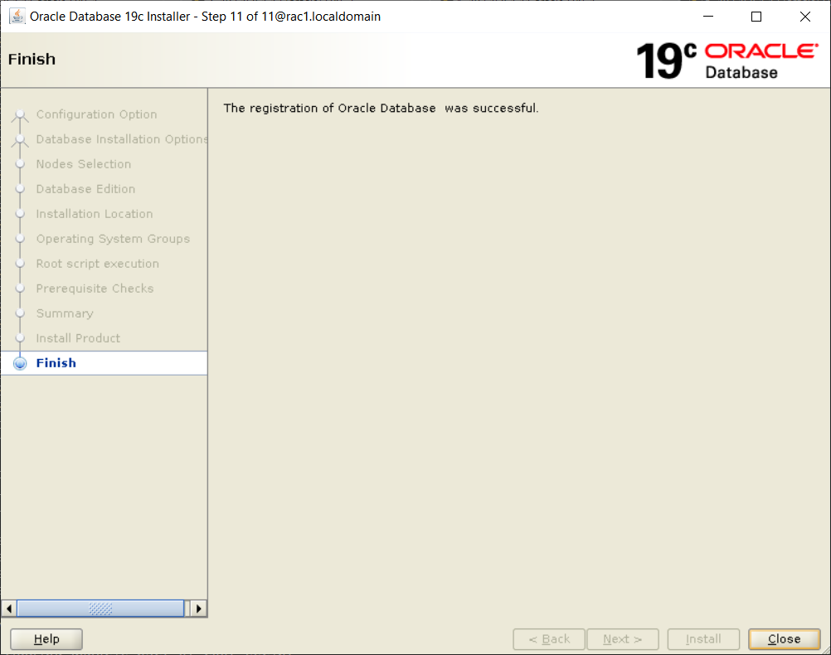

# **Step 20: Tạo diskgroup để cài database – Node 1 - User Grid**

cd

. grid.env

Asmca

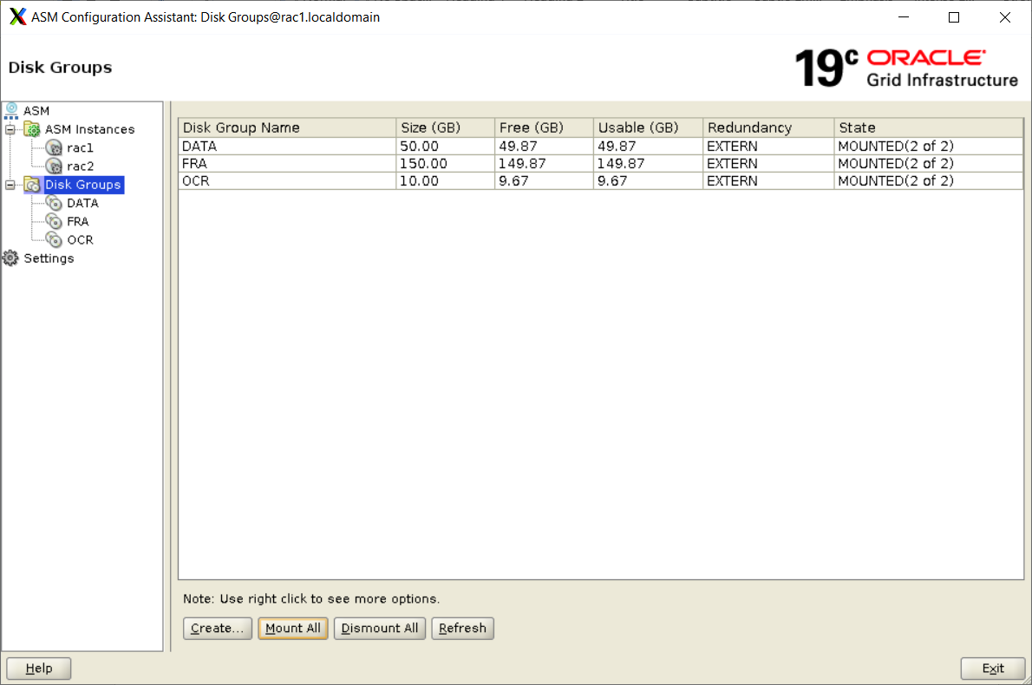

Step 21: Khởi tạo database – Node 1 – User Grid

cd

. .bash_profile

Dbca

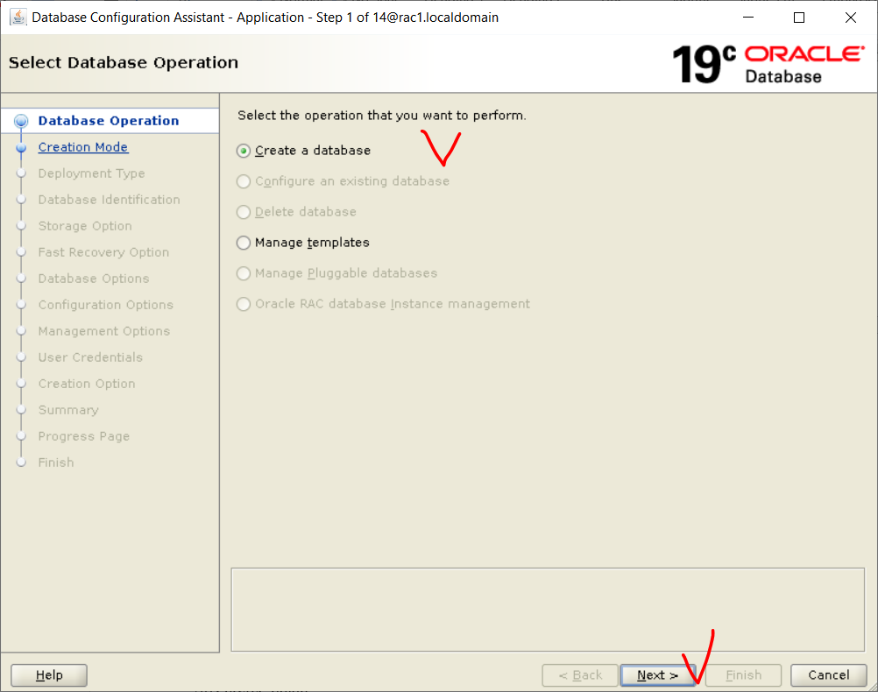

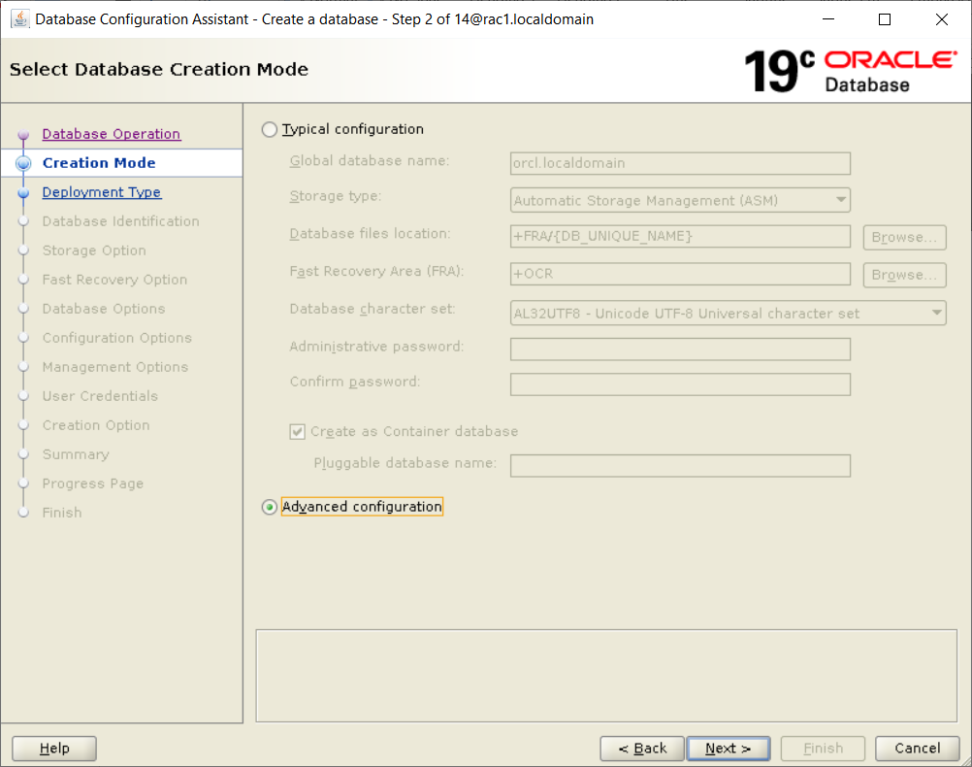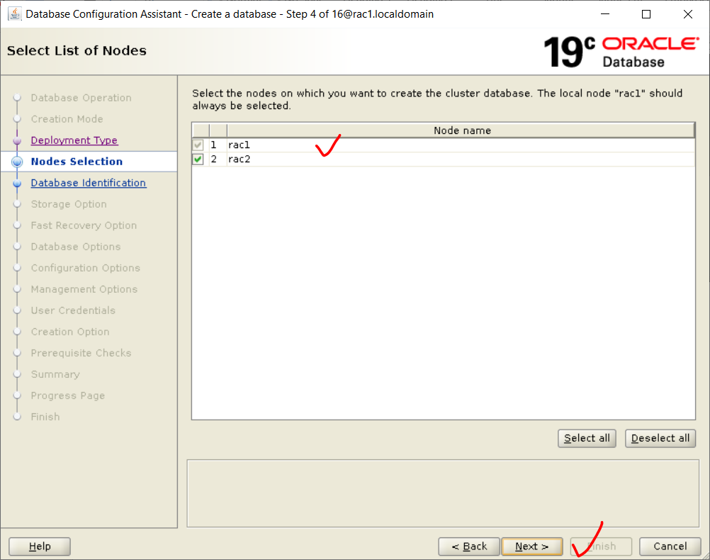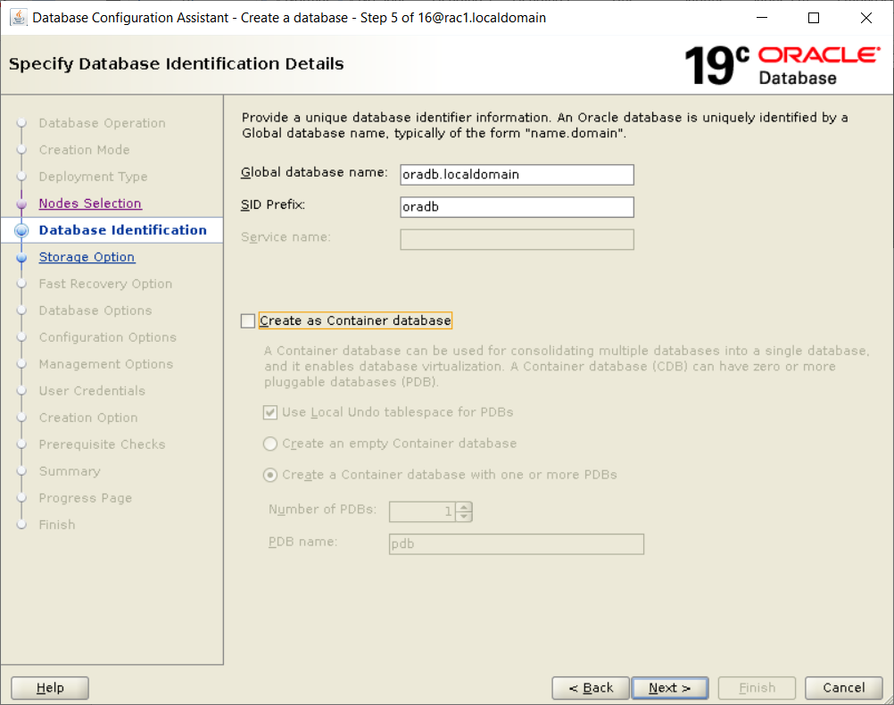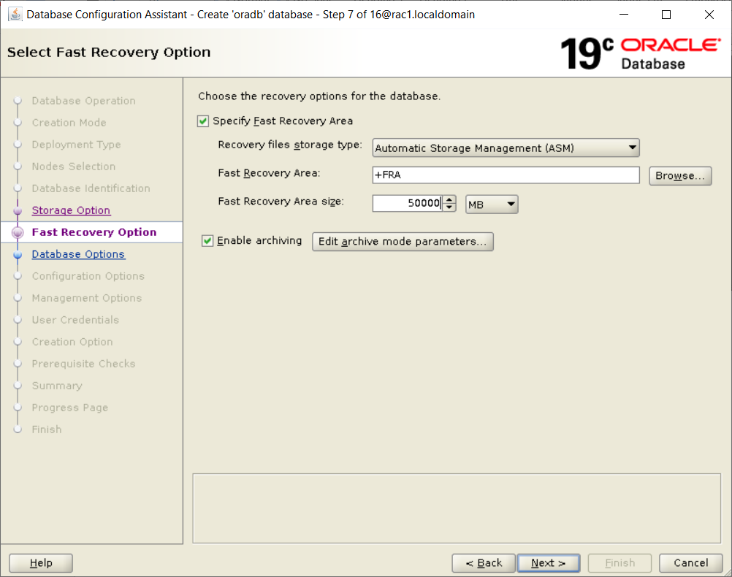

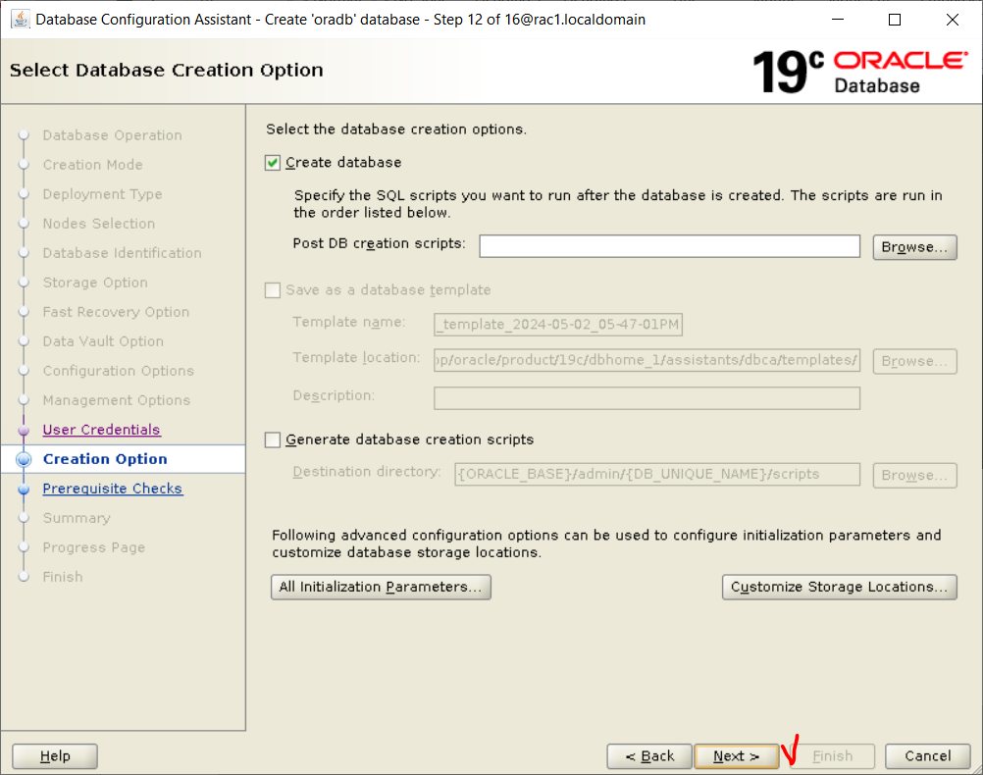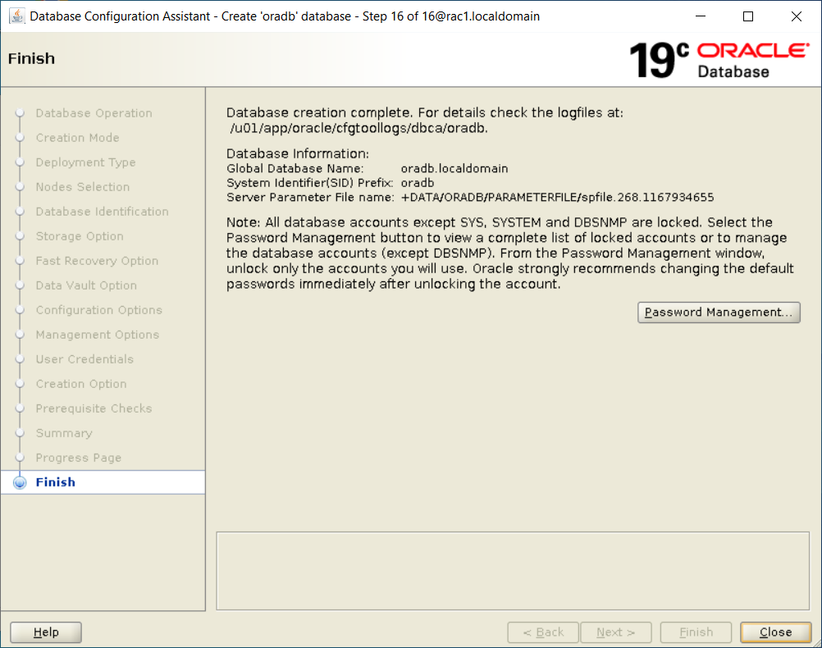

Test dịch vụ: ps -ef | grep pmon

Kiểm tra cluster

/u01/app/19c/grid/bin/crsctl check cluster -all

/u01/app/19c/grid/bin/crsctl status resource -t

Hiển thị danh sách CSDL

srvctl config database

Check asm status

srvctl status asm

srvctl status asm -n rac1

srvctl status asm -n rac2

Danh sách Instance

srvctl config database -d orcl

Danh sách Listener

srvctl config listener